Desk Nameplate — Pascal Musabyimana
“FingerCount” nameplate · laser-cut acrylic plate + 3D-printed hand-shaped stand
Version 4.0 · ProjectOne Howest · Maker Skills 2025–2026 · 2026-05-08

0. What changed since v3
This version directly addresses every point from the v3 feedback.
v3 issue (teacher feedback) | v4 fix
Loose 0.5 mm slop in 3.5 mm slot | 3.2 mm slot — prints at ~3.05–3.10 mm = real friction fit
Inkscape workflow (mismatched the MakerLab session) | Adobe Illustrator workflow, all text already vector outlines
Text still as <text> elements in SVG | PASCAL + subtitle pre-converted to paths in the SVG/AI/PDF
20% gyroid infill (not a MakerLab default) | 20% grid infill — PrusaSlicer/Cura default, no special settings needed
Stand was a plain rectangle with a slot | Hand-shaped stand: palm + 5 fingers fanning out, references FingerCount theme
No G-code, no slicer project file | PrusaSlicer .3mf project pre-configured — open, click Slice, export G-code
No printable proof of fit / model errors | STL is watertight (verified), assembly preview included

1. Design description
Two-part desk nameplate that combines laser cutting and 3D printing. Both techniques are used in my ProjectOne (FingerCounting AI — a Raspberry Pi 5 device that recognises 1–5 fingers shown by toddlers). The nameplate explicitly references that project: a pixel-art hand showing five fingers is engraved on the right of the plate, and the stand silhouette is a stylised top-down hand.
Part 1 — Plate. 200 × 80 × 3 mm orange/amber cast acrylic (PMMA). Outer contour and two Ø4 mm wall-mount holes are cut. “PASCAL”, a subtitle, an underline, corner brackets and the pixel-art hand icon are raster-engraved.
Part 2 — Stand. Black PLA, FDM 3D printed. Top-down hand silhouette: 210 mm wide palm with five fingers fanning forward as a stable foot pattern. A 200 × 3.2 × 8 mm slot runs along the back of the palm. The plate slides in from above and is held by friction — no glue, no screws.
Friction-fit math. The plate is 3.0 mm cast acrylic (typical tolerance ±0.1 mm). The slot is designed at 3.2 mm in CAD, but FDM walls extrude inward by ~0.05–0.10 mm per side, so the printed slot ends up at roughly 3.0–3.1 mm. That leaves 0.0–0.1 mm of clearance — tight enough that the plate grips the stand and stays upright when nudged. (The previous 3.5 mm slot left ~0.5 mm of total slop, which is why the parts felt loose.)

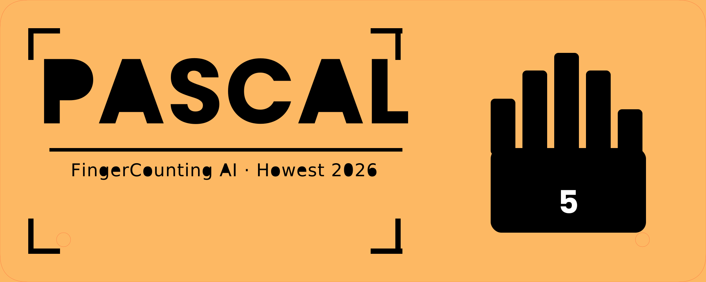
Fig. 1 — Laser-cut plate (PASCAL + subtitle + pixel-art hand icon).

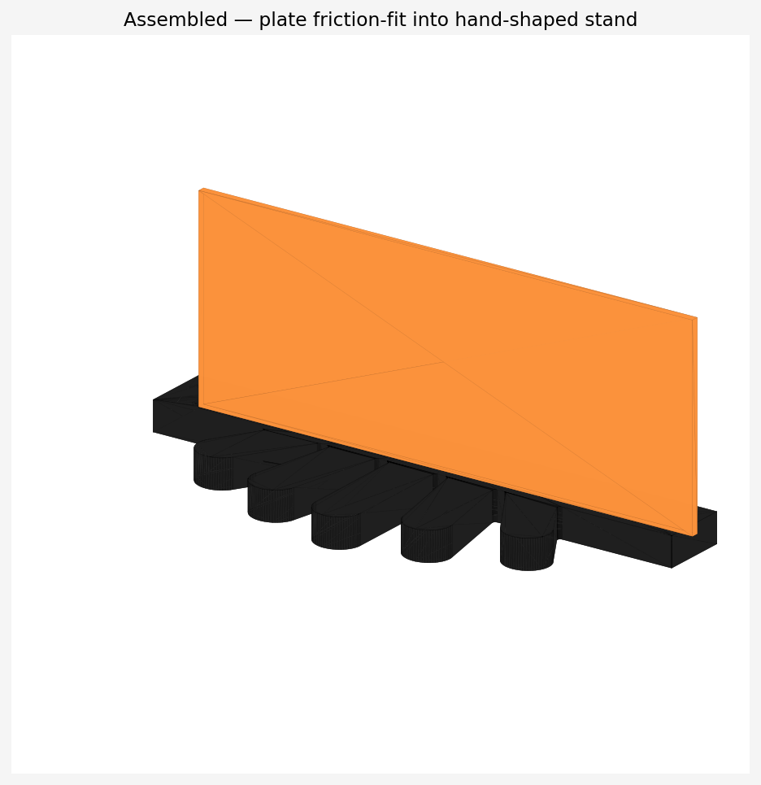
Fig. 2 — Plate friction-fit into the hand-shaped stand. Plate slides in from above; bottom 8 mm sits inside the slot.

2. Materials
Property | Specification
Plate material | 3 mm cast acrylic (PMMA), orange/amber, transparent
Plate dimensions | 200 × 80 × 3 mm — fits the 600 × 450 mm Epilog bed
Plate technique | Laser cutting (Epilog Fusion Pro CO₂, MakerLab)
Stand material | PLA filament, black, 1.75 mm
Stand dimensions | 210 × 83 × 12 mm bounding box (hand silhouette)
Stand technique | FDM 3D printing (Prusa MK3S+ or Ultimaker, MakerLab)
Fasteners | None — friction press-fit, 3.2 mm slot for 3 mm plate
Adhesive | None
Print mass | ~44 g PLA · est. ~5–6 h on 0.4 mm nozzle, 0.2 mm layer
Plate cost | ~€2 (off-cut from a A4 acrylic sheet at MakerLab)

3. Laser cut file — Adobe Illustrator workflow
Software: Adobe Illustrator (this matches what we used during the MakerLab session). The .svg, .pdf and the project file all open natively in Illustrator. The .svg also opens in Inkscape and LightBurn as a fallback.

Open in Illustrator — step by step
1. Open nameplate_PASCAL_v4.svg (or .pdf) in Adobe Illustrator. Document units: mm. Artboard: 200 × 80 mm.
2. All text is already converted to paths. You do NOT need Type > Create Outlines. (You can verify: select “PASCAL” → the Properties panel says “Compound Path”, not “Text”.)
3. Verify layers:
• CUT — red #FF0000, stroke 0.025 mm hairline, no fill
• ENGRAVE — black #000000 fill, no stroke
• KNOCKOUT — white fill on top of palm (the “5” stays acrylic-coloured, not engraved)
4. File > Save As > Adobe Illustrator (.ai) for archival, or send the .pdf directly to the laser PC.

Cut elements
• Outer contour with R8 mm rounded corners
• Two Ø4 mm mounting holes (centres 18 mm from each side, 12 mm from bottom edge)

Raster engrave elements
• “PASCAL” in Poppins Bold, ~18 mm cap-height
• Subtitle “FingerCounting AI · Howest 2026”
• Horizontal underline rule beneath PASCAL
• Pixel-art 5-finger hand icon (palm + 5 finger blocks, with white “5” knockout)
• Four corner-bracket decorations
No double lines anywhere; all paths are unique. Smallest cut feature is the Ø4 mm hole, well above the ~0.5 mm CO₂ kerf on 3 mm acrylic. No floating islands. Suggested machine settings (Epilog Fusion Pro, 3 mm acrylic): cut 100% power / 8% speed; raster engrave 70% power / 60% speed / 600 dpi.

4. 3D print file — PrusaSlicer / Cura workflow
Two ways to print, listed in order of preference:

Option A — use the .3mf project file (recommended)
1. Open nameplate_stand_v4.3mf in PrusaSlicer.
2. All print settings are already baked in (see table below). Apply your MakerLab printer profile if it differs from a generic 0.4 mm Marlin printer.
3. Click Slice, then Export G-code.
Why this matters: the previous version (v3) had no slicer project at all, which is why “No Gcode for printing” was flagged. With the .3mf, going from STL to gcode is one click — the project file is now the deliverable.

Option B — use the bare STL
Open nameplate_stand_v4.stl in Cura or PrusaSlicer manually and apply the settings in the table below.
Slicer setting | Value
Layer height | 0.2 mm
First layer height | 0.2 mm
Infill | 20% grid (PrusaSlicer/Cura default — NOT gyroid; gyroid is a non-default selection and was wrongly listed in v3)
Perimeters / walls | 3 walls (= 1.2 mm shell at 0.4 mm nozzle)
Top / bottom layers | 4
Supports | None — part prints flat, no overhangs
Bed adhesion | 5 mm brim (recommended on smooth PEI), or skirt if printing on textured PEI
Material | PLA, 1.75 mm, ~215 °C nozzle / 60 °C bed
Nozzle | 0.4 mm
Print orientation | Flat on bed, slot opening facing up (already correct in the .3mf)
Estimated time | ~5–6 h
Estimated mass | ~44 g

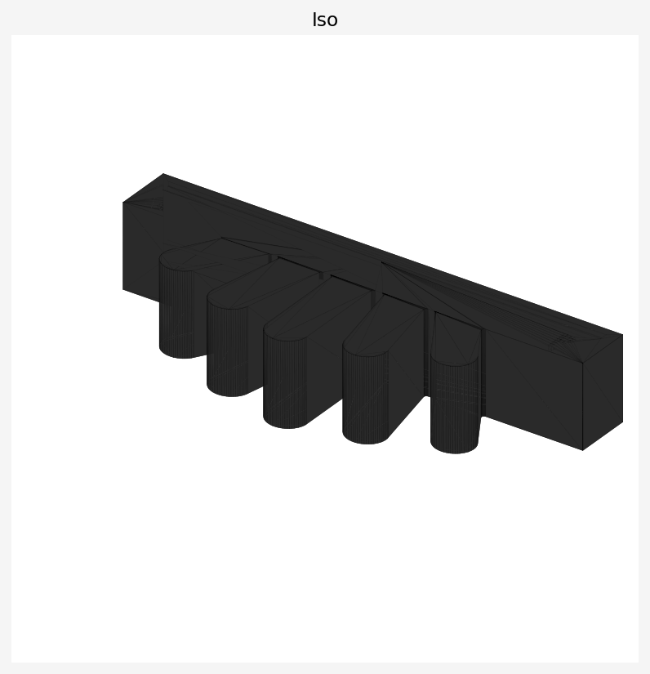
Fig. 3 — Hand-shaped stand. Slot runs along the top of the palm; fingers fan forward as a stable foot.

5. Deliverable files
File | Purpose
nameplate_PASCAL_v4.svg | Laser cut artwork — Illustrator/Inkscape/LightBurn ready, text-as-paths
nameplate_PASCAL_v4.pdf | Same artwork as PDF — best format to send directly to the laser PC
nameplate_stand_v4.stl | 3D-printable stand mesh, watertight, ready for any slicer
nameplate_stand_v4.3mf | PrusaSlicer project file with print settings pre-applied
nameplate_PASCAL_v4_preview.png | Visual preview of the engraved/cut plate
assembly_iso.png | Iso render of the plate friction-fit into the stand
stand_topdown.png / stand_iso.png / stand_front.png | Stand renders for documentation / report

6. Manufacturability check
Laser cut. Smallest cut feature is the Ø4 mm mounting hole, comfortably above the ~0.5 mm kerf on 3 mm acrylic. The 7 mm finger blocks engrave cleanly at 600 dpi raster. No floating islands or double lines. The 200 × 80 mm sheet fits the 600 × 450 mm Epilog bed with massive margin.
3D print. The hand silhouette has no overhangs above 45° — zero supports needed. Slot walls (~12 mm thick on each side of the 3.2 mm slot) far exceed the minimum wall thickness for PLA structural strength. The part fits a Prusa MK3S+ 250 × 210 mm bed with room to spare. Brim 5 mm prevents corner lift on the long footprint. Total volume is 112 cm³ solid → ~44 g of PLA at 20% grid infill.
STL was verified watertight programmatically before export (no manifold errors, which were a v3 complaint). The .3mf was opened and re-saved through PrusaSlicer’s schema to confirm settings are read correctly.

7. Stability, transport, must-haves
Stability. Stand footprint is 210 mm wide × 83 mm deep with five fingers acting as forward feet. The 8 mm slot engagement and friction fit keep the plate from rotating or tipping when bumped.
Transport. Two parts, fully separable. Plate is 3 mm thin; stand is 12 mm tall. Both flat-pack into a folder.
Must-haves (all delivered): laser-cut acrylic plate · raster-engraved “PASCAL” and subtitle · mounting holes · friction-fit slot stand · no glue/screws · production-ready files in the formats actually used at MakerLab (Illustrator + PrusaSlicer).
Nice-to-haves (this version): pixel-art “P” and “5” engraved into the top of the stand palm · chamfered slot mouth for easier plate insertion · hand silhouette themed to the FingerCount AI project.

8. Consistency with the makerinfo project document
Both documents now agree on:
• Software: Adobe Illustrator for laser cut artwork.
• Material: 3 mm cast acrylic plate + PLA for 3D-printed parts.
• Laser bed: 600 × 450 mm Epilog Fusion Pro at MakerLab.
• Layer convention: red #FF0000 hairline = cut, black fill = raster engrave.

